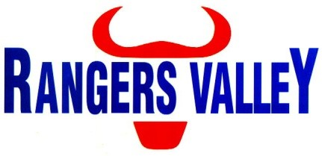

**Manager – Cattle Processing**

Rangers Valley is one of the world’s most respected beef producers. Suppling both Wagyu and Angus brands to discerning customers all over the world. Rangers Valley currently has a full time position available for a Cattle Processing Manager

This is a unique opportunity to be part of a premium beef business with a strong continuing growth strategy.

Reporting to the Manager – Feedlot and External Cattle Operations, this position will be an integral part within the Rangers Valley team and will have key responsibilities that include but not limited to;

* Manage the cattle processing function, cattle movements, and applicable operators.
* Assist in the management of livestock data system and records.
* Drive a safety first culture whilst ensuring compliance with company and legislative WHS requirements.
* Nurturing and developing effective internal and external stakeholder relationships to achieve business objectives.
* Coaching mentoring and development of staff.
* Provide knowledge and support to other departmental managers and Senior Leadership Team.
* Prioritise and manage maintenance and repairs.
* Overseeing livestock data system management.
* Drive best practice methods for animal welfare and environmental practices.

To be successful in this role you will ideally have the following skills and attributes;

* Operational supervisory experience in the cattle processing function within a feedlot environment.
* Practical understanding of WHS requirements.
* Practical understanding of animal welfare, compliance, and quality in a feedlot environment.
* Ability to lead, manage and mentor a team.
* Strong computer literacy and experience with livestock data systems.
* Highly developed problem solving and decision making skills.
* Strong interpersonal skills that allow you to interact and communicate with a range of stakeholders.
* Excellent oral and written communication skills

Desirable attributes for this position are;

* Understanding and experience in a vertically integrated beef supply chain from the feedlot side of a business.
* Management or supervisory experience in more than one operational department within a feedlot.
* Tertiary qualifications in agriculture or animal science.

You will also bring a good attitude and willingness to learn that gives you the ability to work as part of a team as well as autonomously when needed. Also required are excellent organisational and communication skills, coupled with a willingness to integrate with, and add to, the current Rangers Valley business and culture.

An attractive remuneration package based on skills and qualifications is available to the successful applicant.

For further confidential enquiries regarding the position responsibilities or skills required please contact Aaron Childs on 02 6734 4000 or email childsa@rangersvalley.com.au.

To apply please forward applications including cover letter highlighting your experience in line with the required skills as well as your resume to [childsa@rangersvalley.com.au](mailto:childsa@rangersvalley.com.au) or phone 02 6734 4000 for any other enquiries.

Applications close Friday 12th June 2020