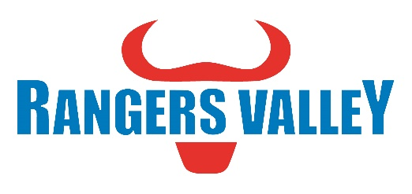
Production Supervisor
Rangers Valley is one of the world’s most respected beef producers. Suppling both Wagyu and Angus brands to discerning customers all over the world. Rangers Valley currently has a full-time position available for a Production Supervisor in the Beef Division.
This is a unique opportunity to be part of a premium beef business working directly with our beef processing partners to deliver great outcomes for our customers.
Reporting to the Production Manager, this position will represent and uphold the Rangers Valley standards within contracted processing plants. Key responsibilities include but not limited to;
- Monitor arrival and handling of cattle to ensure they are in in line with Rangers Valley Standards.
- Monitor Slaughter Floor activities to ensure carcasses are prepared in accordance with Rangers Valley Standards.
- Monitor offal trimming and packing to ensure optimum yield and that packing complies with customer specification.
- Chiller assess carcasses according to Aus-Meat and customer requirements.
- Monitor boning room production to ensure that product is boned, sliced and packaged in accordance with customer specifications and Rangers Valley cut plans
- Liaise with Plant supervisors to identify issues and develop solutions.
- Monitor boning room production to ensure maximum yield recovery and provide the relevant feedback to plant supervisory staff.
- Implement corrective action where processes do not conform to standards or limits.
- Monitor product re-inspection and loadout in line with customer requirements / shipping schedules

To be successful in this role you will ideally have the following skills and attributes.
- Sound detailed technical knowledge of Beef specifications and of beef processing.
- Proven leadership and supervisory capabilities, specifically with Beef Processing plants.
- Experience in AUS-Meat Chilled assessment
- Understand and comply with Workplace Health and Safety standards
- Ability to communicate and work seamlessly with internal and external stakeholders
- Ability to work independently and autonomously as well as in a team environment
- Excellent oral and written communication
- Excellent interpersonal skills
- Experience and proficiency using Excel spreadsheets

You will also bring a good attitude and willingness to learn that gives you the ability to work as part of a team as well as autonomously when needed. Also required are excellent organisational and communication skills, coupled with a willingness to integrate with, and add to, the current Rangers Valley business and culture.
This position is based out of our Brisbane office servicing Rangers Valley’s processing requirements in the South East Queensland region.
An attractive remuneration package based on skills and qualifications is available to the successful applicant.
For further confidential enquiries regarding the position responsibilities or skills required please contact Aaron Childs on 02 6734 4000 or email childsa@rangersvalley.com.au.
To apply please forward applications including cover letter highlighting your experience in line with the required skills as well as your resume to childsa@rangersvalley.com.au or phone 02 6734 4000 for any other enquiries.
Applications close Friday 8th July 2022

