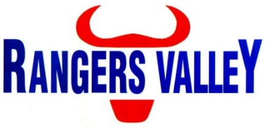

Pen Rider

Rangers Valley Feedlot, on the Northern Tablelands of NSW, specialises in the production of high quality longfed beef. The operation combines a 40,000 head cattle feedlot as well as backgrounding and farming operations.
This is a unique opportunity to be part of a premium beef business with a strong continuing growth strategy.
A pen rider position has become available within the Livestock Crew, this position reports to the Livestock Manager. The position is a full time position on a 10 day on – 4 day off roster.

In this position your responsibilities will include, but are not limited to;
Pen riding and stock movements, monitoring and diagnosis of cattle health, administration of animal health treatments, cattle handling (foot and horses), processing cattle, cleaning and maintenance of water troughs, maintenance of accurate animal health treatments and stock movement records, quality control and compliance with WHS regulations.

Applicants must have competent horsemanship skills, supply own horses and tack, ability to transport own horses and current drivers’ licence. Livestock handling experience is an advantage.
Will suit a person interested in intensive cattle production.

Successful applicants will be motivated self-starters, be able to work within a team environment with a good work ethic and have the ability to work under instruction.

Applications to childsa@rangersvalley.com.au or in writing addressed to:

Manager – HR & Compliance
Rangers Valley Cattle Station Pty. Ltd.
PO Box 63
GLEN INNES NSW 2370

For further information please contact the Manager – HR & Compliance on 02 67344000 or email childsa@rangersvalley.com.au

