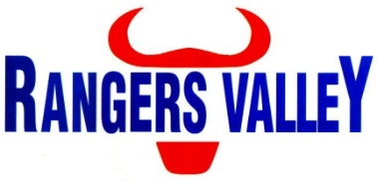

Operator

Rangers Valley Feedlot, on the Northern Tablelands of NSW, specialises in the production of high quality long fed beef. The operation combines a 40,000 head cattle feedlot as well as backgrounding and farming operations.
This is a unique opportunity to be part of a premium beef business with a strong continuing growth strategy.

A position has become available within the Operations Crew, reporting to the Operations Leading Hand. This is a fulltime position with a 5 day on – 2 day off roster including one weekend a month.

This position requires the operation of machinery involved with maintaining feedlot pens, roads and associated infrastructure. In this position your responsibilities will include, but are not limited to;
Operating front end loader, bobcat, tip truck and dog combination, basic maintenance of plant, yard maintenance, maintain basic record keeping and compliance with WHS regulations.

Truck license (HC, MC or HR) is required.

Experience with operating an excavator and/or grader will be an advantage.

Successful applicants will be motivated self-starters, be able to work within a team environment with a good work ethic and have the ability to work under instruction.

Applications to childsa@rangersvalley.com.au or in writing addressed to:

Manager – HR & Compliance
Rangers Valley Cattle Station Pty. Ltd.
PO Box 63
GLEN INNES NSW 2370

For further information please contact the Manager – HR & Compliance on 02 67344000 or email childsa@rangersvalley.com.au

