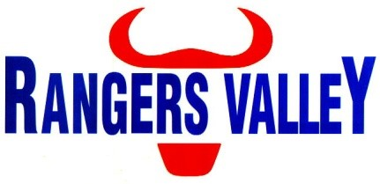

**Business Development Manager**

Rangers Valley is one of the world’s most respected beef producers. Suppling both Wagyu and Angus brands to discerning customers all over the world. Rangers Valley currently has a full time position available for a Business Development Manager.

This is a unique opportunity to be part of a premium beef business with a strong continuing growth strategy.

Reporting to the Meat Division Manager, this position will be an integral part within the Rangers Valley team and will have key responsibilities that include but not limited to;

* Nurturing and developing effective internal and external stakeholder relationships.
* Using your market knowledge and sales skills to drive the brand's presence into additional markets and strengthen sales with existing customers.
* Developing effective and tailored sales actions, plans and targets
* Maintaining effective relationships with customers through communication and frequent liaison.
* Liaising with the logistics teams
* Ad hoc administrative and clerical duties.
* Complete costing models and data analysis
* Drive efficiency and innovation within the business development function

To be successful in this role you will ideally have the following skills and attributes;

* Prior sales experience with a proven track record of results
* Have at least 5 years’ experience in a beef sales.
* Detailed knowledge of Beef specifications & an understanding of beef processing.
* Ability to work independently and autonomously as well as in a team environment
* Excellent oral and written communication
* Excellent interpersonal skills
* Experience and proficiency using Excel spreadsheets;
* Excellent communication skills when dealing with both internal and external stakeholders.

Desirable attributes for this position are;

* Understanding and experience in a vertically integrated beef supply chain.
* Export meat sales experience.
* Tertiary qualifications in sales or marketing.

You will also bring a good attitude and willingness to learn that gives you the ability to work as part of a team as well as autonomously when needed. Also required are excellent organisational and communication skills, coupled with a willingness to integrate with, and add to, the current Rangers Valley business and culture.

The successful applicant will be able to be based at either our Brisbane or Warwick offices, with occasional travel required.

An attractive remuneration package based on skills and qualifications is available to the successful applicant.

For further confidential enquiries regarding the position responsibilities or skills required please contact Aaron Childs on 02 6734 4000 or email childsa@rangersvalley.com.au.

To apply please forward applications including cover letter highlighting your experience in line with the required skills as well as your resume to [childsa@rangersvalley.com.au](mailto:childsa@rangersvalley.com.au) or phone 02 6734 4000 for any other enquiries.

Applications close Monday 19th December 2022