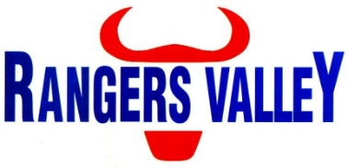

Feed Truck Driver

Rangers Valley Feedlot, on the Northern Tablelands of NSW 30km from Glen Innes, specialises in the production of high quality long fed beef. The operation combines a 40,000 head cattle feedlot which as well as backgrounding and farming operations.

This is a unique opportunity to be part of a premium beef business with a strong continuing growth strategy.
A Feed Truck Driver position has become available within the Feed Crew, reporting to the Mill Supervisor. This position is full time on a 10 day on – 4 day off roster.

This position requires the operation of feed trucks which disperse feed throughout the feedlot. In this position your responsibilities will include, but are not limited to;
Operating a feed tuck, commodity handling, basic maintenance of plant, general feedlot yard maintenance, maintain basic record keeping and compliance with WHS policy, procedures, and regulations.

No prior experience is necessary, training will be provided.

A truck license is not required for this position.

Experience with operating a loader and/or other plant will be an advantage.

Successful applicants will be motivated self-starters, be able to work within a team environment with a good work ethic and have the ability to work under instruction.

Accommodation may be available.

Applications to childsa@rangersvalley.com.au or in writing addressed to:

HR & Compliance Manager
Rangers Valley Cattle Station Pty. Ltd.
PO Box 63
GLEN INNES NSW 2370

For further information please contact the Manager – HR & Compliance on 02 67344000 or email childsa@rangersvalley.com.au

