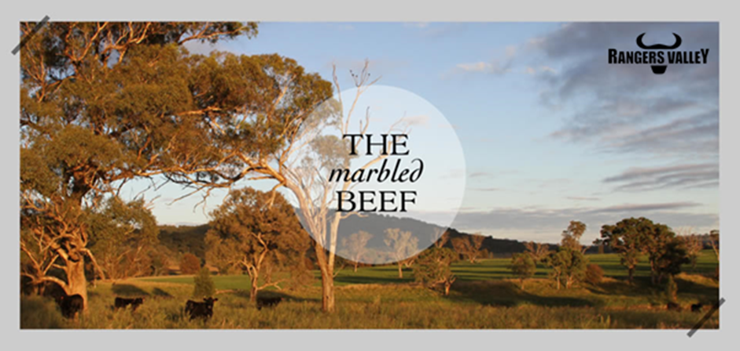

Livestock Manager
Rangers Valley is one of the world’s most respected premium beef producers. Supplying both Wagyu and Angus brands to discerning customers all over the world. Rangers Valley currently has a full-time position available for Livestock Manager based at Rangers Valley Feedlot.
This is a unique opportunity to be part of a premium beef business with a strong continuing growth strategy.
Reporting to the Manager - Feedlots and External Cattle Operations, this vital hands-on role will be responsible for the daily management of the feedlots’ livestock operations.
This position will be an integral part within the Rangers Valley team and will have key responsibilities that include but are not limited to;
- Providing leadership across the livestock department, ensuring a safe and productive work environment.
- Lead the livestock team in the health management of cattle.
- Oversee the effective coordination of feedlot animal health (including pen riding, diagnosis and treatment).
- Plan and organise cattle movements as needed.
- Ensure that all regulatory and compliance requirements are met.
- Provide management with reports and information as required.
- Ensure all work is being undertaken in line with WHS policy and procedures.

To be successful in this role, you will ideally have the following skills and attributes;
- Minimum three years of feedlot experience.
- Knowledge and ability in animal husbandry techniques in a feedlot environment.
- Experience in team management and leadership.
- Sound horsemanship skills.
- Experience in consulting with external veterinary and nutritional consultants.
- Well-developed problem-solving and decision-making skills.
- Intermediate computer skills.
- Current driver's licence.

Familiarity with NFAS accreditation and QA systems and procedures will be an advantage.

You will also bring a positive attitude and willingness to integrate with and add to the current Rangers Valley business and culture.
An attractive remuneration package, including onsite housing, is available to the successful applicant.
If you are looking at an opportunity to work for one of the world's most respected premium beef producers, please forward applications, including a cover letter highlighting your experience in line with the required skills as well as your resume, to childsa@rangersvalley.com.au or phone 02 6734 4000 for any other enquiries.
For further confidential enquiries regarding the position responsibilities or skills required, don't hesitate to contact Aaron Childs on 02 6734 4000 or email childsa@rangersvalley.com.au.
Applications close Wednesday, 31st May 2023.

