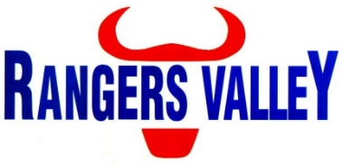

Induction / Cattle Processing

Rangers Valley Feedlot, on the Northern Tablelands of NSW, specialises in the production of high quality long fed beef. The operation combines a 40,000 head cattle feedlot as well as backgrounding and farming operations.
This is a unique opportunity to be part of a premium beef business with a strong continuing growth strategy.
A position has become available within the Induction / Cattle Processing Crew, reporting to the Cattle Processing Manager. This position is full time on a Monday – Friday roster.

In this position your responsibilities will include, but are not limited to;
Administration of animal health treatments, cattle handling (on foot), processing cattle, cleaning and maintenance of water troughs, maintenance of accurate computer records, quality control and compliance with WHS regulations.

Above award hourly rates paid.

Accommodation options supplied if required.

Previous experience is an advantage, but not necessary.

Applications to childsa@rangersvalley.com.au

For further information please contact the HR & Compliance Manager on 02 67344000 or email childsa@rangersvalley.com.au

