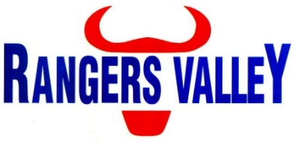

Feedyard Maintenance

Rangers Valley Feedlot, on the Northern Tablelands of NSW, specialises in the production of high quality longfed beef. The operation combines a 40,000 head cattle feedlot as well as backgrounding and farming operations.
This is a unique opportunity to be part of a premium beef business with a strong continuing growth strategy.

A position has become available undertaking feedyard and property maintenance, reporting to the Maintenance Manager. This position is full time Monday to Friday role with some overtime as required.

In this position you will be required to carry out repairs and maintenance as well as some new work to maintain the feedyard and property infrastructure.

Your responsibilities in this position will include, but are not limited to;
General maintenance, welding, machinery operation, basic maintenance of plant and equipment, assisting with larger fabrication works, maintaining water infrastructure, following works as per set program and compliance with WHS regulations.

Welding experience is essential.

Truck license (HR, HC or MC) will be advantageous.

Successful applicants will be motivated self-starters, with an ability to work autonomously and under instruction in a team environment.

Applications to r in writing addressed to:

Manager – HR & Compliance
Rangers Valley Cattle Station Pty. Ltd.
PO Box 63
GLEN INNES NSW 2370

For further information please contact the Manager – HR & Compliance on 02 67344000 or email childsa@rangersvalley.com.au

