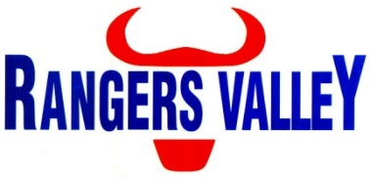

Pen Rider

Rangers Valley Feedlot, on the Northern Tablelands of NSW, specialises in producing high-quality long-fed beef. The operation combines a 40,000-head cattle feedlot and backgrounding and farming operations.
This is a unique opportunity to be part of a premium beef business with a strong continuing growth strategy.
A full time pen rider position has become available within the Livestock Crew; this position reports to the Head Stockman. The position is a full-time position on a ten-day on – 4-day off roster.
We are looking for fit, positive people to join our livestock team and undertake responsibilities including, but not limited to;
Pen riding and stock movements, monitoring and diagnosis of cattle health, administration of animal health treatments, cattle handling (on foot and horses), processing cattle, cleaning and maintenance of water troughs, maintenance of accurate animal health treatments and stock movement records, quality control and compliance with WHS regulations.
Applicants must have competent horsemanship skills, preferably be able to supply their own horses and tack and have a current driver’s licence.
Above award hourly rates, tack and shoeing allowances are paid as well as other allowances if applicable, including a horse allowance.
Horses and accommodation options supplied if required.
Successful applicants will be motivated self-starters, be able to work within a team environment with a good work ethic and have the ability to work under instruction.
Previous feedlot experience is an advantage but not necessary.

Applications to childsa@rangersvalley.com.au

For further information please contact the Manager – HR, IT & Compliance on 02 67344000 or email childsa@rangersvalley.com.au

