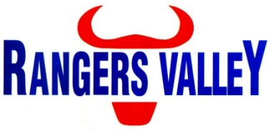

Farm Hand

Rangers Valley Feedlot, on the Northern Tablelands of NSW, specialises in the production of high quality long fed beef. The operation combines a 40,000 head cattle feedlot as well as backgrounding and farming operations.
This is a unique opportunity to be part of a premium beef business with a strong continuing growth strategy.

A new position has become available within the Farming Crew, reporting to the Manager – Farming and Environmental Reporting. This is a fulltime position with a Monday to Friday roster, with weekend work as required and above award wages.

This position requires:

- The ability to maintain and operate a range of machinery, including tractors, front end loaders and boom sprays.
- Experience using GPS
- Experience with both winter & summer planters
- Centre Pivot irrigation operation & maintenance
- Spraying, fencing & general on farm duties
- Able to work unsupervised
- Chem cert or a willingness to obtain
- HC truck licence or be willing to obtain
- A positive attitude, attention to details, willingness to learn, and excellent communication skills

Mechanical and fabrication experience with oxy, welding etc will be an advantage.

Successful applicants will be motivated self-starters with a positive attitude a willingness to learn and excellent communication skills.

Please forward applications to careers@rangersvalley.com.au

For further information please contact the Manager – HR, IT & Compliance on 02 67344000 or email childsa@rangersvalley.com.au

